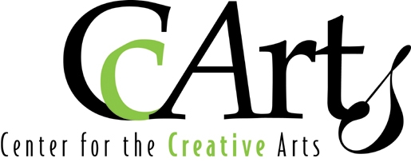
March, 2019
Dear Artists,
Please join us as an artisan at the Center for the Creative Arts for our Annual Artisan’s Show on November 23 and 24, 2019. Our show features the work of unique and talented fine art and crafts artists from the region. We typically attract 850 to over 1,000 guests to this two-day event. We have many dedicated shoppers who look forward to coming to this event each year to bring art into their homes and to find unique items for their holiday shopping needs. You can see some examples of last year’s artwork on our face book page for the event: https://www.facebook.com/CCArtsArtisansShow/
We’ll promote the event with ads, postcards, social media and broadcast emails. We will again have a food truck, drinks and snacks for sale and offer complimentary water, coffee/tea/hot chocolate to vendors throughout the weekend. CCArts is a not-for-profit community organization that strives to make the arts available to everyone. One of the ways we accomplish this is through a raffle of Artisan’s items. We’d love to have a donation of an item, which is optional but very much appreciated. We ask that if you can donate, choose an item with a value of at least $20. You will receive a thank you letter with the value of your item for tax purposes. We also invite you to demonstrate your craft if it suits you to do so. We cannot provide extra space for it so only choose this if you feel it will enhance the experience for your customer and help to make a sale. We will make a note of it in the event brochure if you demonstrate.
We look forward to your participation in our event!
Sincerely,
Terry Foreman
PLEASE READ ALL POLICIES, RULES AND INSTRUCTIONS
CCArts Annual Artisan’s Show Nov 23 & 24, 2019
Entry Procedures
- Submit the application. No fees are due at this time so apply early for the best consideration.
- Submit 5 good quality color photos or digital images of each type of your work to be sold. See details on application. Label images with your name and a number, i.e. PICASSO 1, PICASSO 2, etc. (if emailing, your images should have your last name and the image number in the filename) Applications without images will not be considered. Electronic images (jpeg) of 200 dpi or better must be supplied for the show webpage, and advertising use. Images should be good quality, 250k to 2MB in file size. Email images to: info@ccarts.org
Eligibility
- Handmade original designs with a high level of craftsmanship are required. All entries are judged by the vendor committee for quality and suitability for our show. The committee makes the final decision on the items chosen.
- Buy-sell items, mass produced items or items made from kits are unacceptable.
- Exhibitors shall exhibit only work represented in the photos presented with the application. Vendors will be asked to remove any items not approved in the application process. CCArts reserves the right to ask the vendor in violation to leave the show without refund of entry fee.
Exhibit Space
- Spaces are approximately 10X10, 10X8, 8x8 or 8x8 flexible. Work and personal belongings, such as table, chairs, and boxes, must be contained within assigned space and tables should be draped to the floor.
- CCArts occupies an old elementary school building. Artisan spaces in classrooms may vary in shape; we ask that artists bring flexible displays. Furniture and equipment in the classrooms may not be moved without permission.
- If customers will need to walk around your display, allow room within your allotted space, not around the perimeter. Please plan your display accordingly.
- If extra room is needed, please apply for two spaces.
- Lighting is overhead; we recommend you bring additional lighting for your display. CCArts reserves the right to limit the number of lights in each booth as needed to prevent power outages.
- Display lighting and extension cords are not provided, please bring your own. You may wish to label them with your name, as side by side booths may both be using extension cords.
- All tables should be draped to the floor and all storage containers are stowed and out of sight.
- Wifi is available for using credit card machines. We are working to improve the coverage each year.
- There will be two set up options, Friday before the show from 11am-6pm and Saturday, 8am-10am.

Selection / Notification

- All applicants will be judged by the Artisan’s Show committee. Entries will not be considered if they do not comply with the rules of this application. Entries will be considered solely on the merits of work pictured in the images sent with your application.
- Acceptance will be emailed / mailed as applications are judged and accepted. Spaces will be assigned as acceptable applications are received, so apply early to increase chances of being accepted and getting preferred space assignments.
- Refunds must be requested before November 1, 2019. A $25 processing fee will be deducted. After Nov. 1st, refunds are at the discretion of the artisan committee.

Return application and payment to;
Attn: Artisan Show
Center for the Creative Arts
PO Box 146,
1149 Yorklyn Rd.
Yorklyn, DE 19736-0146

www.ccarts.org

Contact: Terry Foreman 302-239-2434
tforeman@ccarts.org

Vendor Application – CCArts Annual Artisans Show
Saturday, November 23, 2019 10:00am – 5:00pm
Sunday, November 24, 2019 10:00am – 5:00pm

Name: _____________________________ Business Name: ___________________________________________
Address: ____________________________________________________________________________________
City: _________________________________________ State: _________________ Zip: ____________
Phone # _______________________________ Cell # ______________________________
Email __________________________________________________________________________
Are you new to the Artisan’s Show? Yes No Medium: _____________________________________________
Please describe your artwork: _________________________________________________________________________________________________________________________________________________________________________________________________________________________________________________________________ Price Range: Low $ _______ High $ ________
Space options: Check 1st and 2nd choice with a “1” and a “2” and include number of spaces requested. See diagrams of types of spaces on the next page.
______ $200 10X10 square Auditorium, Corner booth, open on 2 sides (i.e. #2, #6, #7)
______ $185 10X10 square Auditorium, open on 1 side (i.e. #1, 3, 4)
______ $175 8X10 rectangle in Classroom, Corner booth, open on 2 sides (i.e. #2, #6, #7)
______ $165 8X10 rectangle in Classroom, Regular booth, open on 1 side (i.e. #1, #3, # 4)
______ $150 approximately 8X8 Classroom, Flexible (varying shapes, may be an L shape)
Would you like to be placed in a specific room? If so, please specify a first and second choice by writing a “1” and a “2” next to that room.
Yellow ___ Purple ___ Blue ___ Green ___ Pink ___ Red ___ Auditorium ___ Any Room ___
Would you like to have some postcards to promote the event? If so, how many would you like? ____
Can you pick them up from the Center, or do you need them mailed to you? I will pick up. Please mail them to me.
Continued on next page

Booth Design
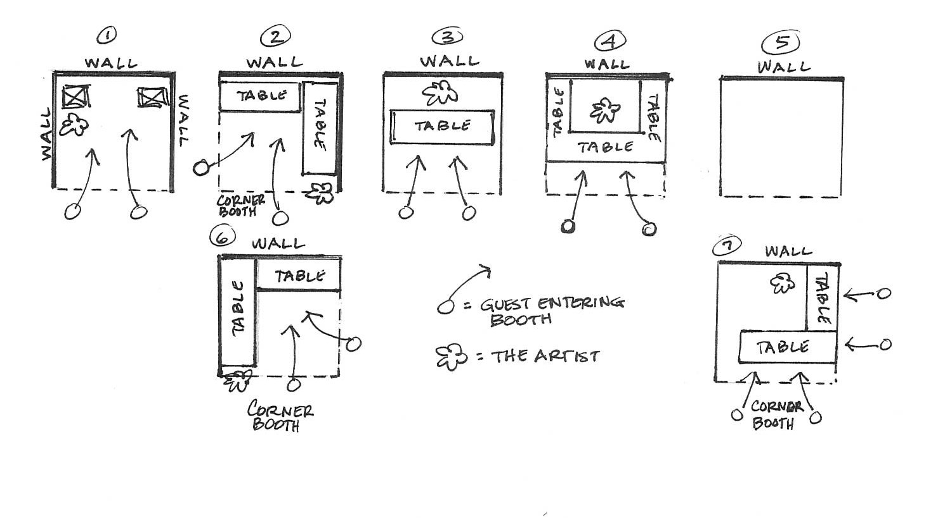
We would like to learn from you about the design of your booth set up so we can provide the best layout possible for the show. Some booth designs require that they be in a corner or on the end of a row (#2, #6, #7). Booths with 3 tall sides (#1), such as ones used to display fine art, are often best in the back corner of a room and not near the entry way which can block the view into the room. Let us know which one is the closest style to your booth. It will also indicate which category of space you should be reserving. The larger and more access your space has to customers, the higher the fee will be. A booth with two open sides will need to be assigned to a corner so as not to block your neighbor. If none of these diagrams describe your booth, make a sketch in the empty box (#5) and show us your set up. If you’re unsure about which category of booth to reserve, write us a note on your application and we’ll get in touch with you.
Which booth layout closest represents your booth design? 1 2 3 4 5 6 7
Unsure Please provide some details: ________________________________________________
Will you need: Electricity: Yes - $10.00 No Will you demonstrate your art form? Yes No
Do you want our tables and chairs?
1 set of: 6’ Table & 2 Chairs: Yes No (First set is free, additional tables are $5 each)
Extra table How many? _____ x $5 each = $ ______

Total Fees Submitted with this application: $ ______
Would you like to donate an item valued at $20 or greater to our Raffle table? Yes No

Jurying Requirements:
Please provide 5 digital images of your work, representative of what you wish to sell at the show. Out of the 5 images, you may include an image of your booth if you have one. Also include at least one close-up image of your work. (just one artwork in the image, not a group arrangement) Images should be good quality, 250k to 2MB in file size. Please indicate here how you wish to share these images with us. Please check one:
Will email images CD enclosed Thumb drive enclosed

I have enclosed the registration, electric and additional table fees for the 2019 Artisan’s Show. I am aware that the high cost of insurance makes it prohibitive for CCArts to carry insurance on artwork exhibited or sold on the CCArts premises. I understand that the Center for the Creative Arts is not liable for any claim, loss or damage of any kind to my exhibit or me and I agree to release and hold them harmless for such liability. I agree to allow images of my work to be used in event related publicity or materials. Spaces will be invoiced in August and fees due on September 15, 2019. No fees are due with this application, so apply early for best consideration.
By signing this form, applicant acknowledges that all work is original and agrees to abide by all rules set forth in the application.
Vendor Signature ___________________________________ Date ___________________

